**Library Management System**

**User Manual**

All Rights Reserved 2023

**Collection Management**

* **Add a New Material / Collection**

1. Click **List** tab**.**
2. Click **Add New Collection** button.
3. A **form** will appear for you to fill up the needed information.

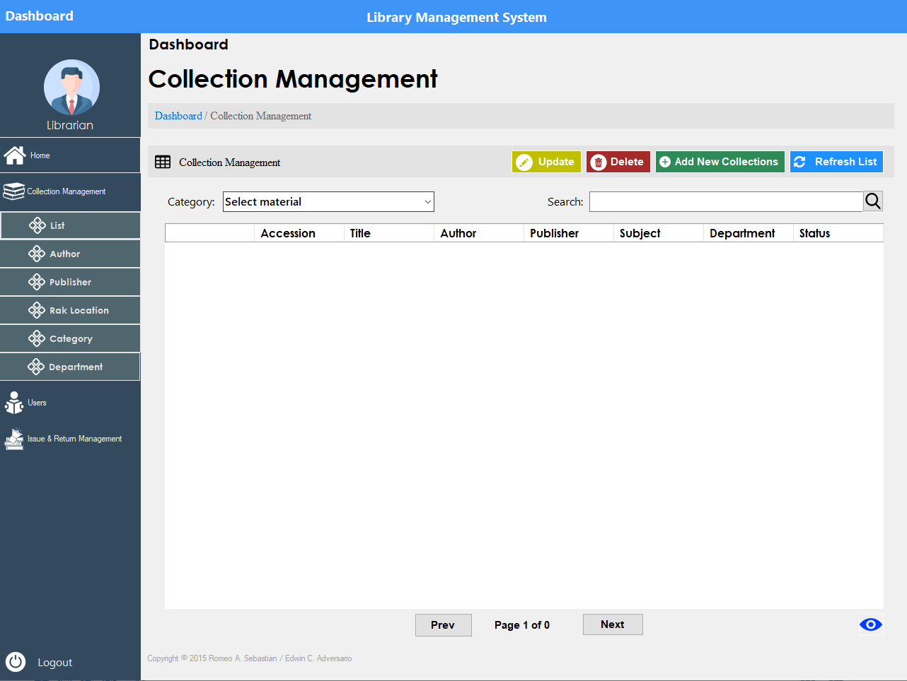

**1.**

**2.**

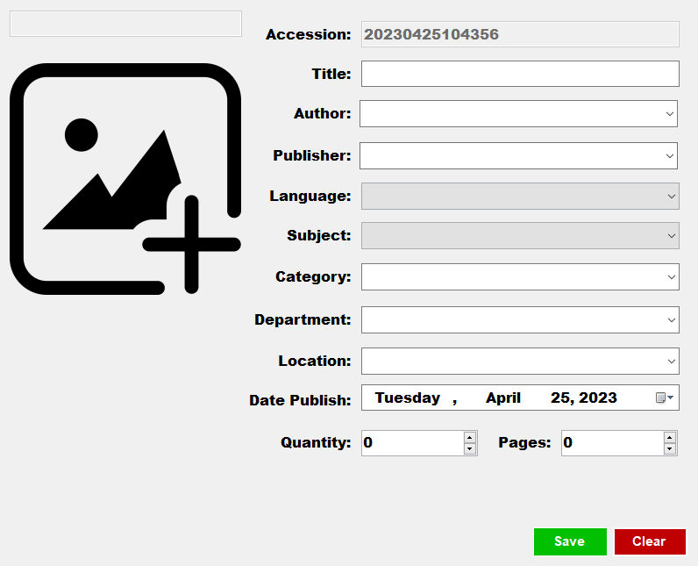

**3.**



This feature is to filter the category of the collections in the table, either book, article, archives etc.



You search specific collection using this search bar.

This feature enables you to see the full details of the collection.



* **Delete Material / Collection**

1. Click **Delete button**
2. A **confirmation message** will appear where you need to choose “yes” or “no”.

*Note: you can only delete a material if the status is “Not Available”.*

* **Add a New Author**

1. Click the **Author** tab**.**
2. Click **Add New Author** button.
3. A **form** will appear where you need to put the information needed.

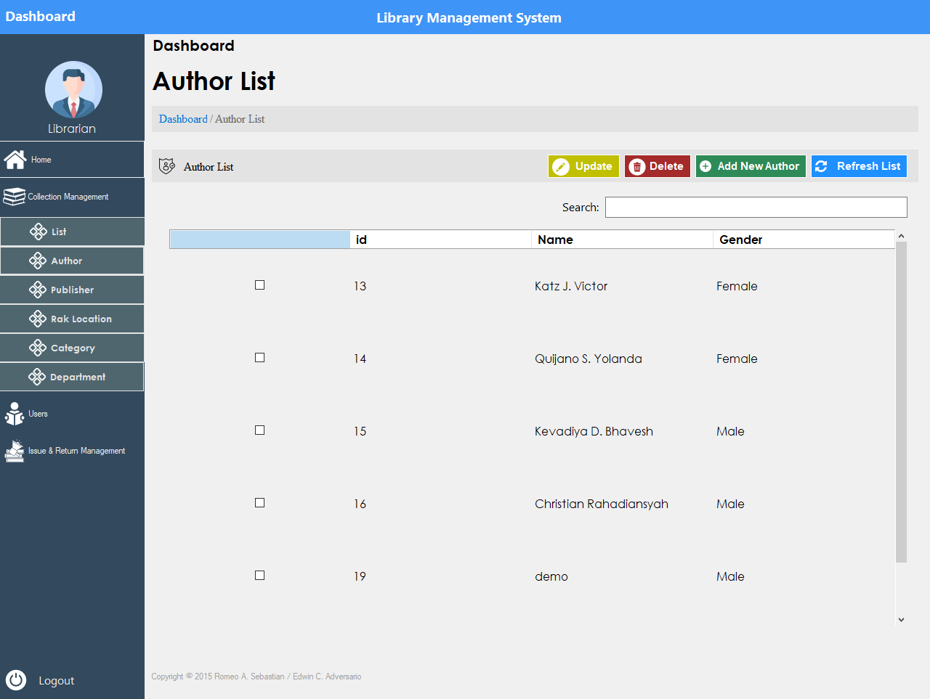

**1.**

**2**.

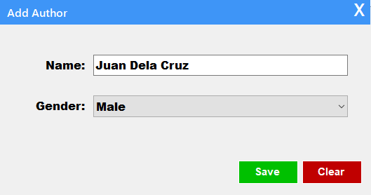

**3**.



This button is for deleting author in the table.

This button is manually refreshing the table, when you add or delete.

**Add New Publisher**

1. Click the **Publisher** tab**.**
2. Click the **Add new Publisher** button.
3. A **form** will appear where you need to put the information needed.

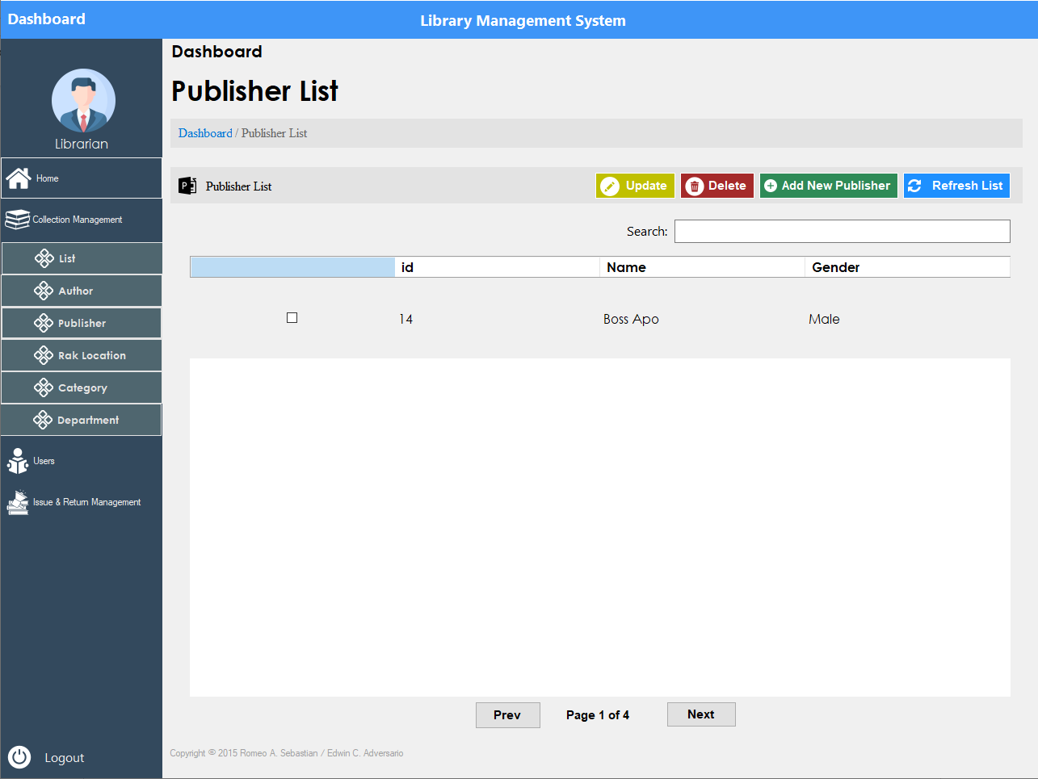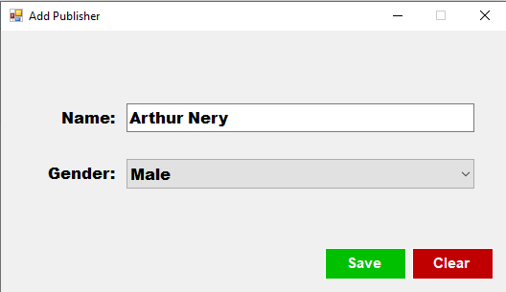

**1.**

**2.**

**3.**



This button is for deleting publisher in the table.

This button is manually refreshing the table, when you add or delete.

**Issue and Return Management**

* **Return Material**

1. Click **Issued List** tab.
2. Select the specific **library Id** using checkbox.
3. Then click **Return** button**.**

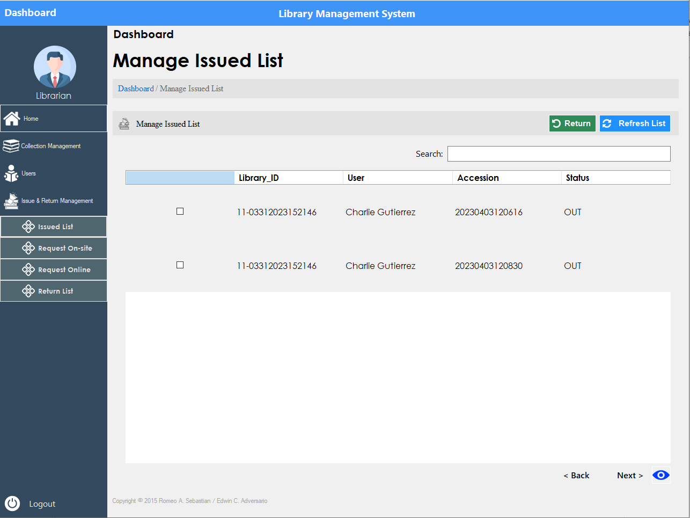

**1.**

**2.**

**3.**



This button is to see the full issued details of the account.

* **Request Onsite**

1. Click **Request Onsite** tab.
2. Select a **material** using check box.
3. Then click **Issue Book** button.
4. **Form** will appear where you need to search the **library Id** of the student.

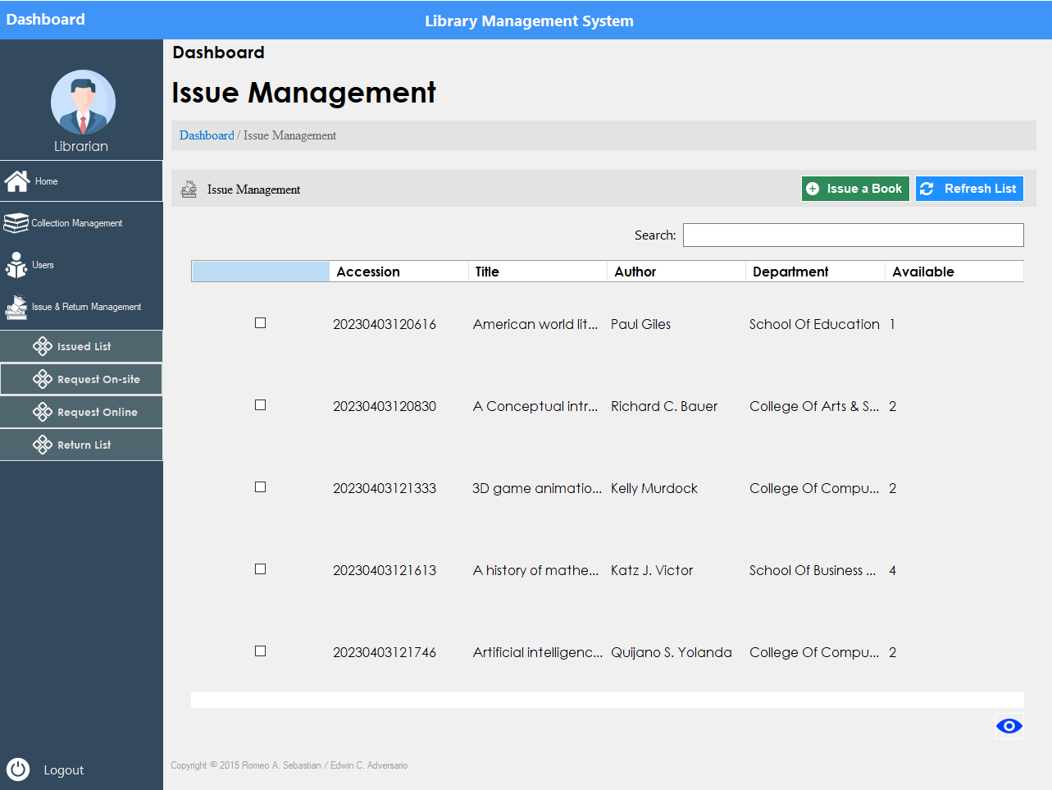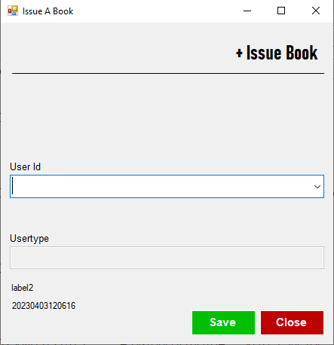

**1.**

**2.**

**3.**

**4.**



You can also search the material or any collection that you need to find using this search bar.

* **Request Online**

1. Click **Request Online** tab.
2. Select a **request** in the table using check box.
3. Then click either “**Reject**” or “**Approve**”.

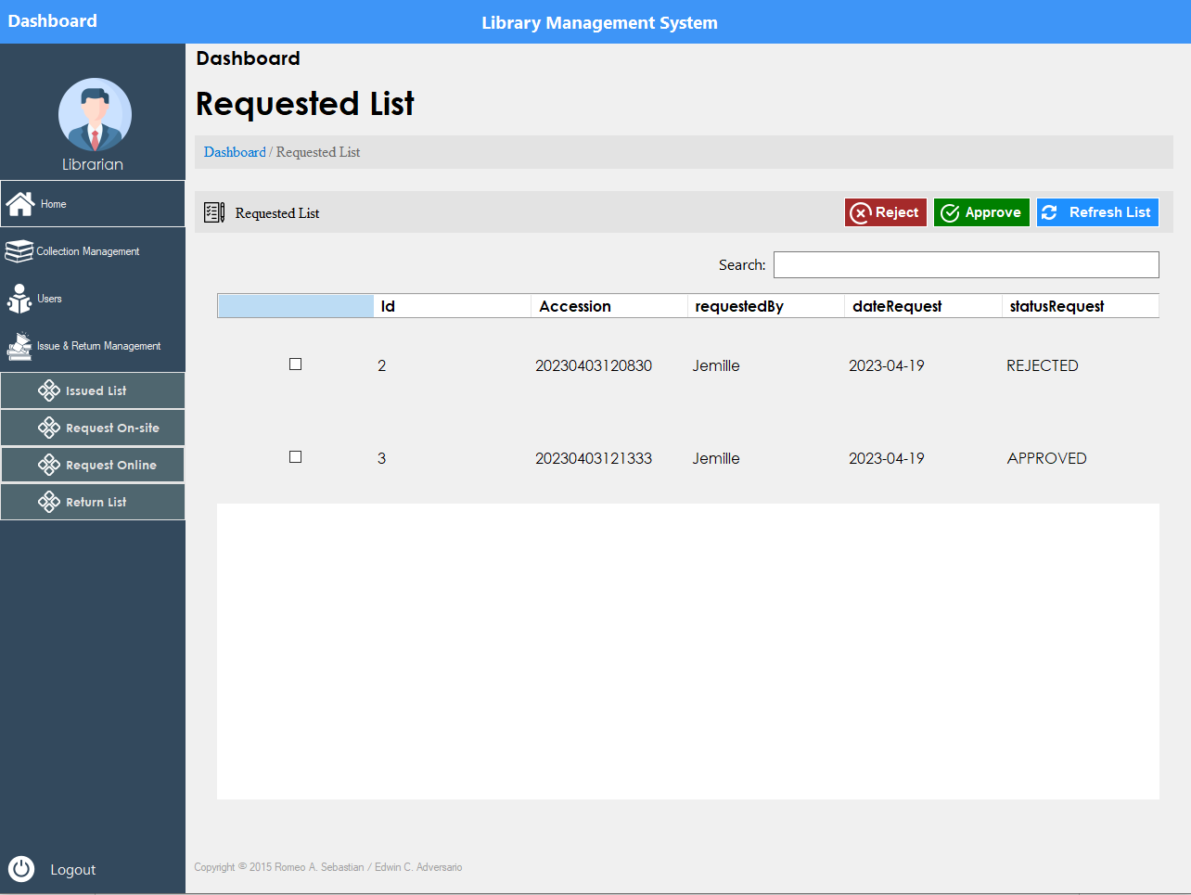

**1.**

**2.**

**3.**

* Return List

1. Click **Return list** tab.
2. **Select** the data you desire.
3. Click the **eye** icon to see the full details of the data.

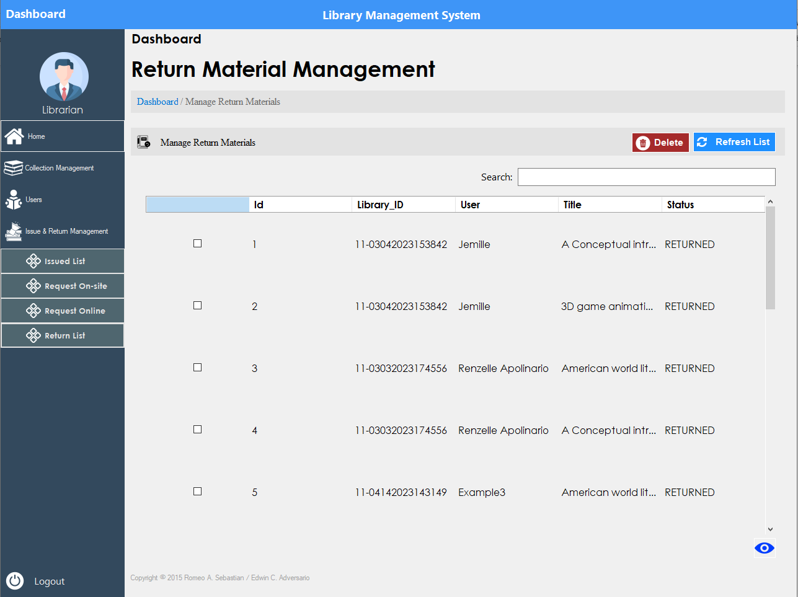

**1.**

**3.**

**2.**



If you want to delete a data, you need to select a data in the table then click this delete button.